Procedure to install stata 12(64-bit)

Here the procedure explains how to install stataSE12 in windows operating system.

Firstly you have the state setup file, Run the setup file of stata12MSI

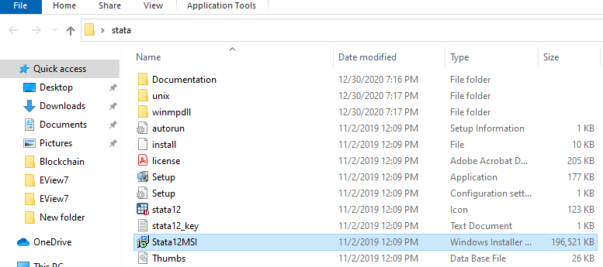

Click on "Next" to installation of Stata 12

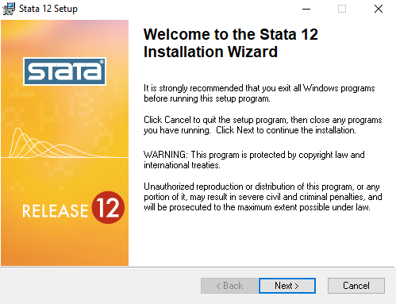

Select "I accept the license agreement" and click on "Next".

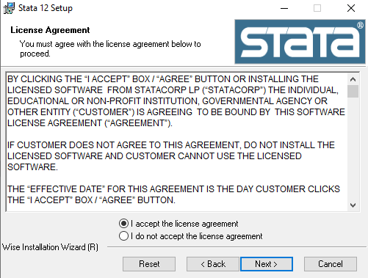

Enter the 'Full Name' and 'Organization' , select Anyone who uses this computer after that click on 'Next'.

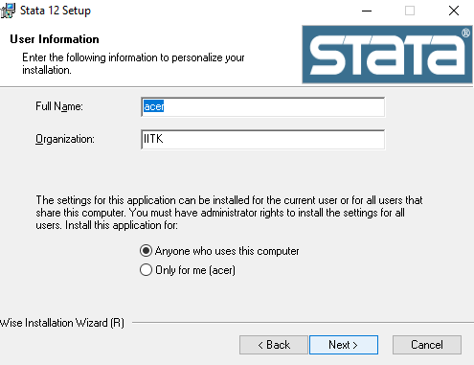

Select Executable Flavor 64-bit SE then Click on 'Next'

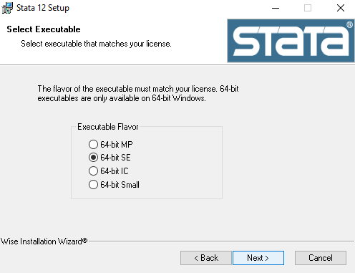

Select Destination Folder then Click on 'Next'

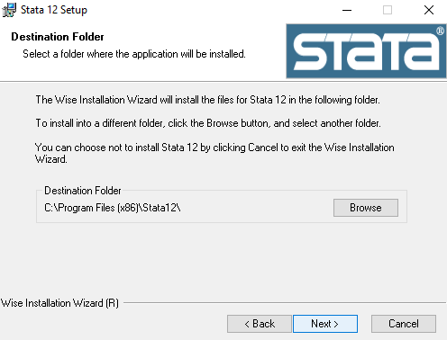

Select Default Working Directory and Then Click on 'Next'.

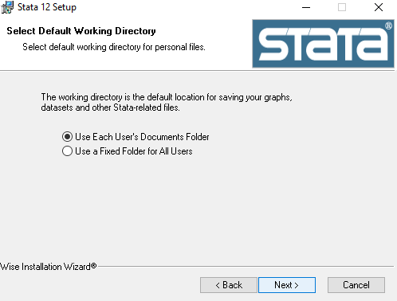

Then Ready to Install the Application and Click on 'Next'.

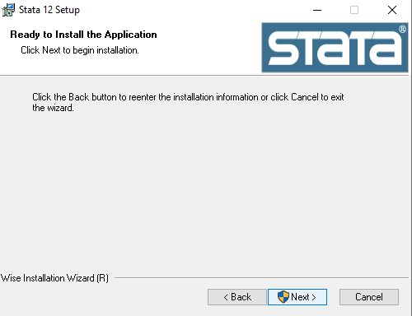

Updating component registration.

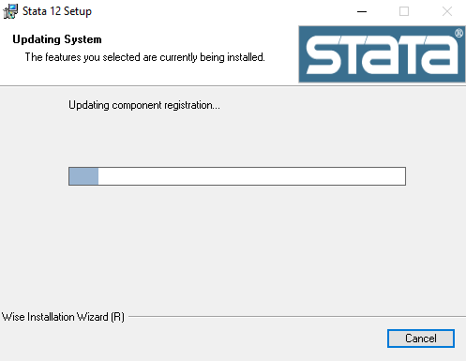

Successfully Stata 12 has been installed then Click Finish.

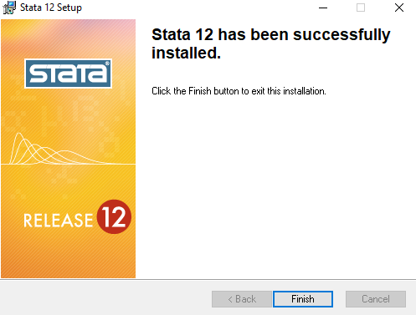

..................................................................................................................................................................................................

Designed by Shyam Singh